**ASSIGNMENT - 8**

**–Qn 1.Create view vw_updatable_products (use same query whatever I used in the training)**

**Try updating the view with the below query and see if the product table also gets updated.**

**Update query: UPDATE updatable_products SET unit_price = unit_price * 1.1 WHERE units_in_stock < 10;**

**QUERY**

--Create a view

create view vw_updatable_products as

select product_id,product_name,unit_price,units_in_stock

from products;

--update query

update vw_updatable_products

set unit_price = unit_price * 1.1

where units_in_stock < 10;

--Verifying the products table after updating the view

select product_id,product_name,unit_price,units_in_stock

from products

where units_in_stock<10;

**OUTPUT**

*AFTER UPDATING*  *BEFORE UPDATING*

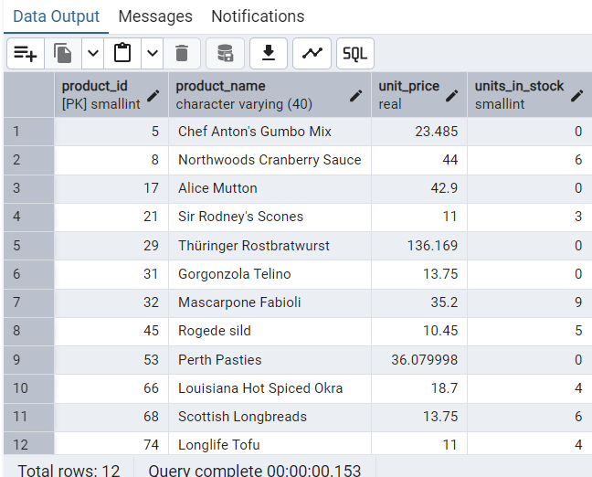 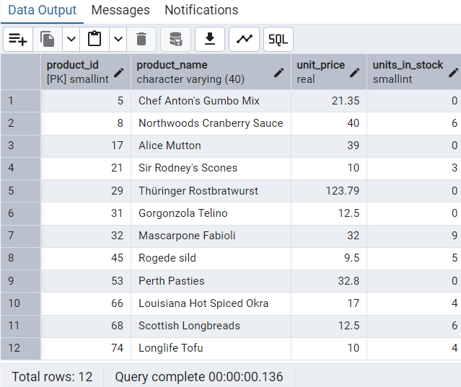

**–Qn2.Transaction: Update the product price for products by 10% in category id=1**

**Try COMMIT and ROLLBACK and observe what happens.**

**QUERY**

begin;

update products

set unit_price = unit_price * 1.1

where category_id = 1;

-- View changes before committing

select product_id,product_name,unit_price

from products

where category_id = 1;

--committing the transaction

COMMIT;

--rollback

ROLLBACK;

**OUTPUT**

*Updating category_id*

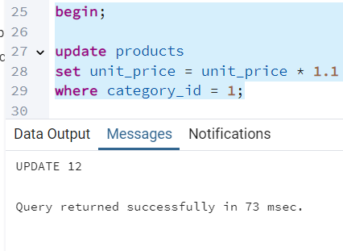

*Before updating category_id*  *After updating category_id*

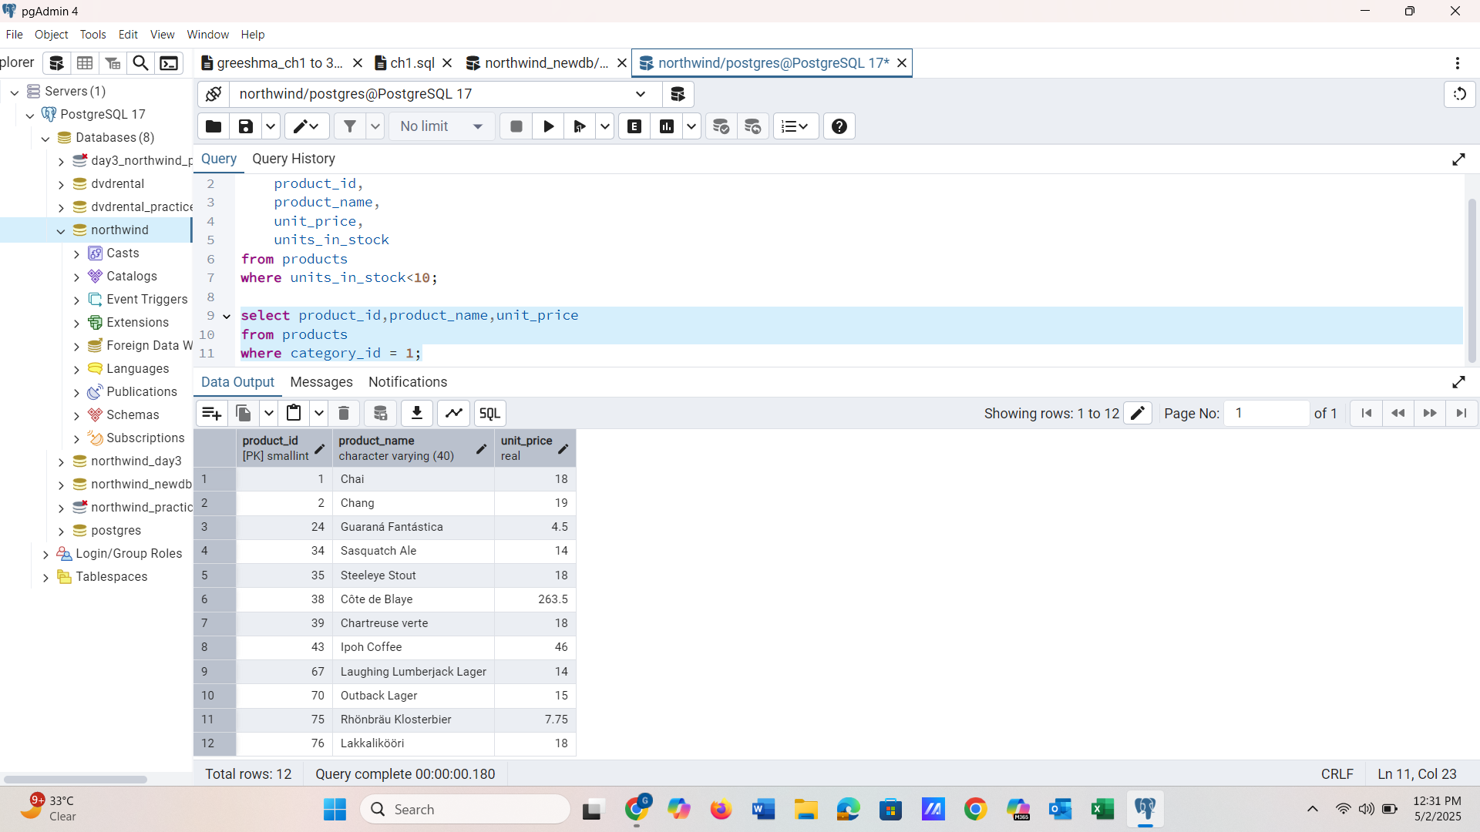 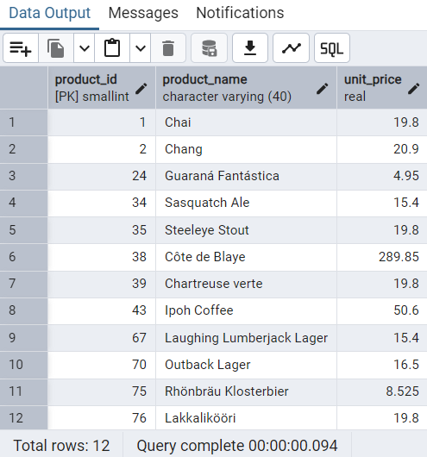

*Committing Transaction*   *Rollback*

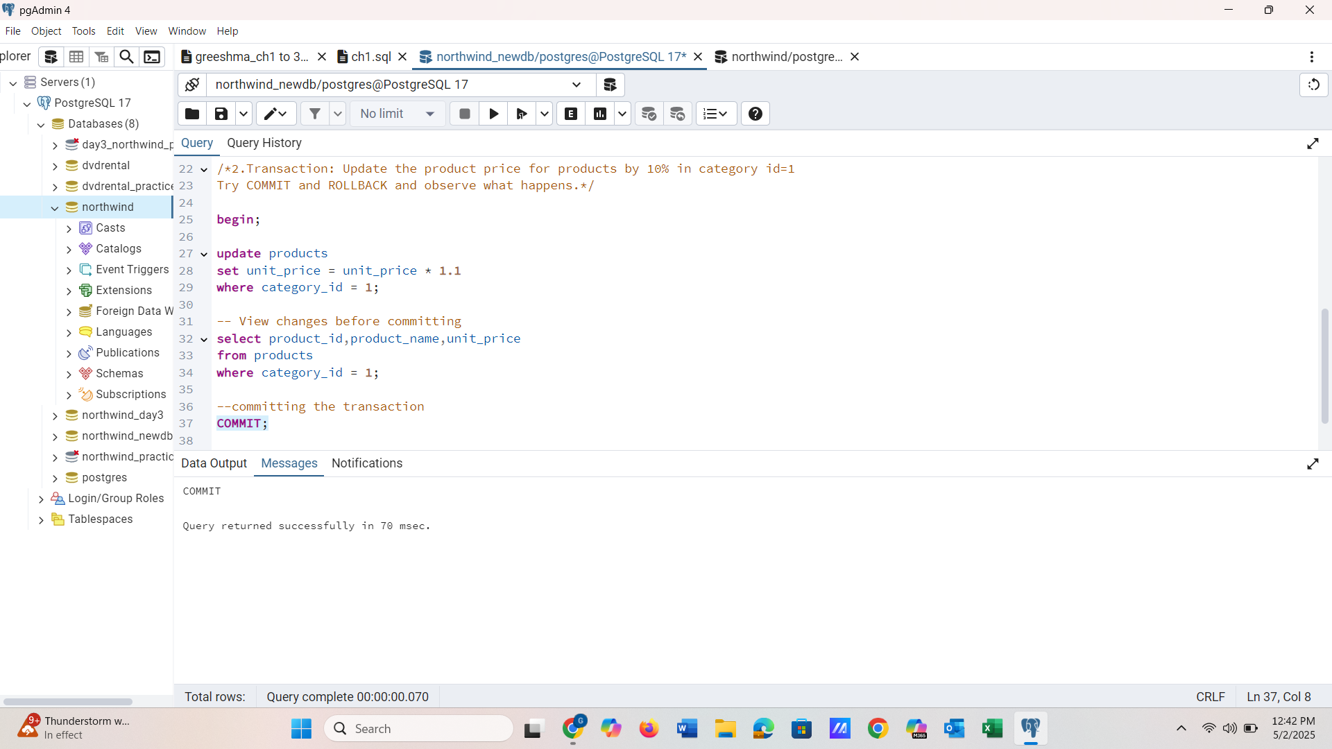 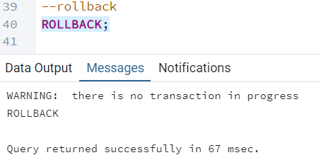

**–Qn3.Create a regular view which will have below details (Need to do joins):**

**Employee_id,Employee_full_name,Title,Territory_id,territory_description,region_description**

**QUERY**

create view vw_employee_territories as

select

e.employee_id,

concat(e.first_name, ' ', e.last_name) as employee_full_name,

e.title,

et.territory_id,

t.territory_description,

r.region_description

from employees e

join employee_territories et on e.employee_id = et.employee_id

join territories t on et.territory_id = t.territory_id

join region r on t.region_id = r.region_id;

select * from vw_employee_territories;

**OUTPUT**

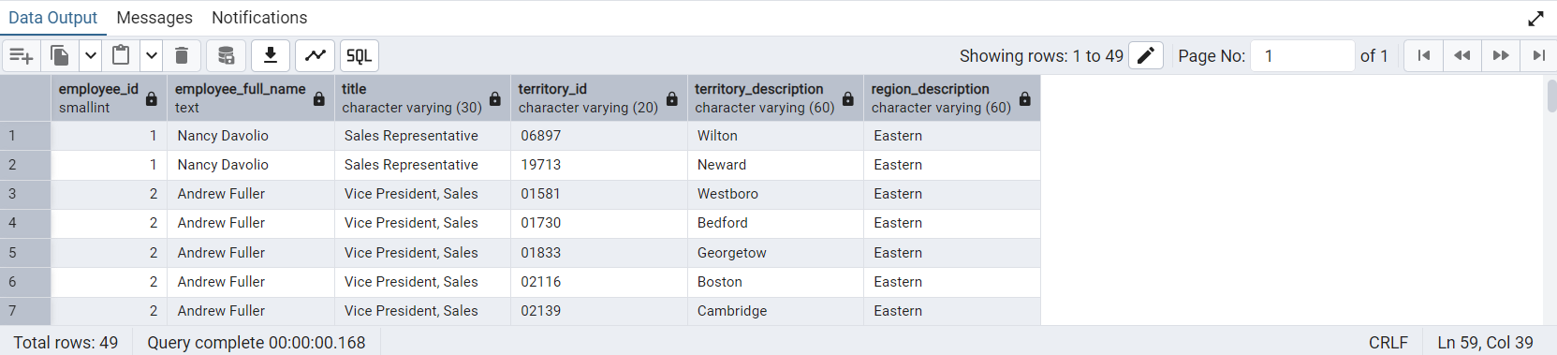

**–Qn4.Create a recursive CTE based on Employee Hierarchy**

**QUERY**

*-- Anchor member: top-level employees (no manager)*

with recursive employee_hierarchy as (

select employee_id,first_name,last_name,reports_to,1 as level

from employees

where reports_to is null

union all

*-- Recursive member: employees reporting to others*

select e.employee_id,e.first_name,e.last_name,e.reports_to,eh.level + 1

from employees e

inner join employee_hierarchy eh on e.reports_to = eh.employee_id

)

select *from employee_hierarchy

order by level, employee_id;

**OUTPUT**

